  

**Centre Name: ACE – HCMC – 2 – FPT**

**Address: 590 Cach Mang Thang 8 Street – District 3 – Ho Chi Minh City - Vietnam**

Installation Guide

|  |  |  |
| --- | --- | --- |
| **Faculty:** | **Mr. Hoai Vu** |  |
| **Batch No:** | **T1.2302.E1** |  |
| **Group No.:** | **03** |  |
| **Students:** | **Full Name** | **Roll No.** |
| 1. | NGÔ ĐÌNH TÂN | Student1455765 |
| 2. | PHAN VĂN GIỮ | Student1455761 |
| 3. | NGUYỄN THỊ NGỌC MAI | Student1457506 |
| 4. | NGUYỄN THÀNH NHÂN | Student1455763 |
|  |  |  |

11 July, 2024

System Requirements

|  |  |
| --- | --- |
| **HARDWARE REQUIREMENTS** | |
| ***Minimum*** | |
| **ADMIN/ USERS** | * Intel core I7. * 8GB RAM. |
| ***Recommended*** | |
| **ADMIN/ USERS** | * Intel core I5. * 8GB RAM or higher. |
| **SOFTWARE REQUIREMENTS** | |
| **ADMIN/USERS** | * Microsoft® Windows 8/10/11. * Visual Studio.Net / ASP * IIS Server * SQL Server * Visual Studio Code * Nodejs Environment |

**Folder Structure**

--eProject3

--Documentation

--Source Code

--Front-end

--Back-end

--Database

1. **Front-end**
2. Install library

* Go to front-end source

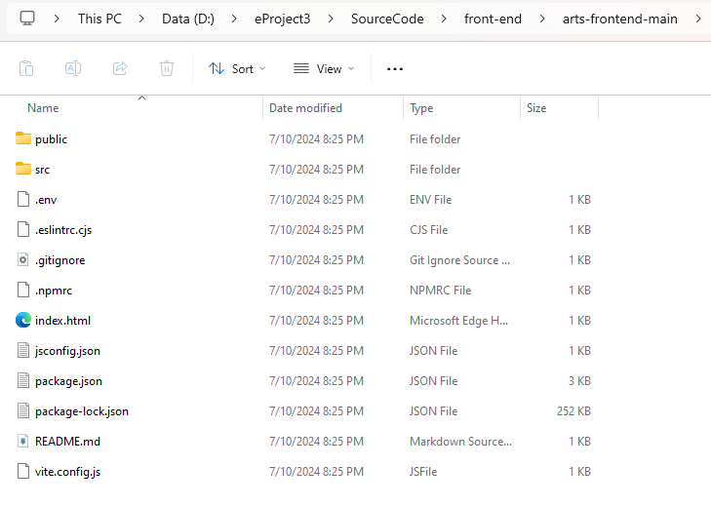

-

-

* Right-click and **open with Terminal**

**-**input **code .**  and wait for Visual Studio Code appear

* After that, input **npm install** and waiting for library successfully install

1. Run front-end app

In visual studio code CLI, input **npm run dev**

Local: <http://localhost:5173/> is the url of the application but don’t go quick

1. **Database**
2. Open the SSMS
3. Right-Click to Database and select **Import-Data tier**

1. When the Pop-up appear Select Next

1. Select **Import from local disk** and select file database.bacpac

1. The database will be created when successfull

1. **Back-end**
2. Get the Connection string

* Go to the path like this and double click arts-core.sln

1. When the Visual Studio open SQL Server Object Explorer -> click icon Add Sql Server

1. Input Server Name and change Trust Server Certificate to true

1. When connection success, select database created before -> Right -Click-> PropertiesA screenshot of a computer

   Description automatically generated
2. Find Connection String and copy value

Example: Data Source=NHANNT;Initial Catalog=database;Integrated Security=True;Connect Timeout=30;Encrypt=True;Trust Server Certificate=True;Application Intent=ReadWrite;Multi Subnet Failover=False

1. Open file aspsetting.json and change pasted it

**EVERYTHING IS DONE . GO TO THE WEBSITE AND EXPLORE IT**

ADMIN ACCOUNT

USERNAME: admin@admin.com

PASSWORD:admin

